Situation Based MCQ
1. Anita is helping her father with the honey bees . Select the most important thing she should do when near the beehive.
a.make a loud noise
b. wear a protective suit
c. disturb the bees
d. run away
2. A company is building a new road through a forest. As a student of EVS choose the environmental issue caused by this on animals living there-
a. increase their food sources
b.provide them with new habitats
c. disrupt their migration pattern
d. improve their living conditions
3. You have migrated from Village to city to study in a good school. Migration is one of the reason for which families changes. It may also happen due to
a. marriage party
b. going on vacation
c. having a birthday party
d. a change in job or career
4. In an activity students made games and sports with rules. Why are rules important in games and sports?
a. for doing discrimination
b. to stop winning
c. fair play and sportsmanship
d. for arguments
5. Assertion (A): Partition of countries bring suffering to their citizens.
Reason (R): Citizens feel happy to get a new house and new livelihood.
a. Assertion is correct but reason is not justified.
b. Assertion is not correct but reason is justified
c. Both are correct and justified.
d. Both are incorrect .
6. Suppose your younger sister fell down and she got a cut in her arms and bruise in her knees. Choose the flower that you will use to sooth her pain?
a. Rose
b. pumpkin
c. Marigold
d. Lotus
7.


After observing the two animals in the picture, what comes in your mind.
a. Both are extinct animals.
b. One is extinct animal .
c. Both are endangered animals.
d. One is extinct and the other one is endangered animals.
8. In a train journey you would prefer to sit beside a window seat-
a. to sleep.
b. to talk with others.
c. to enjoy the scenic beauty outside.
d. to ensure security.
9. You have observed that many flowers bloom at night . The pollinators are attracted towards them as they have-
a. bright colour.
b. strong fragrance.
c. strong taste.
d. dull appearance.
10. The path to your school is a bit uneven and rocky. Select the kind of vehicle that would be most suitable to travel.
a. A car
b. A motorcycle
c. A bullock cart
d. A bicycle
11. When a symbiotic relationship benefits both the organisms ,it is an example of-
a. Commensalism
b. Mutualism
c. Parasitism
d. Amutualism
12. Assertion (A): You have seen that when a train moves from one state (Goa) to another state (Karnataka) the scenic beauty outside the window changes.
Reason (R): This happens due to the speed of the train.
a. Assertion is correct but reason is not justified.
b. Assertion is not correct but reason is justified
c. Both are correct and justified.
d. Both are incorrect .
13. A Zoo has a pair of white tigers. The zoo staff is very careful to protect them and provide them with a good habitat. Why are they doing this?
a. To make the tigers happy.
b. To prevent the tigers from becoming extinct.
c. To make the zoo look pretty.
d. To make the tigers famous.
14. Suppose millions of years ago fossil fuels were not formed in the earth’s crust. On the bases of this, what would be the present situation .
a. Limited technological development.
b. Increase in population.
c. Increase in pollution.
d. Decrease in renewable resources.
15.
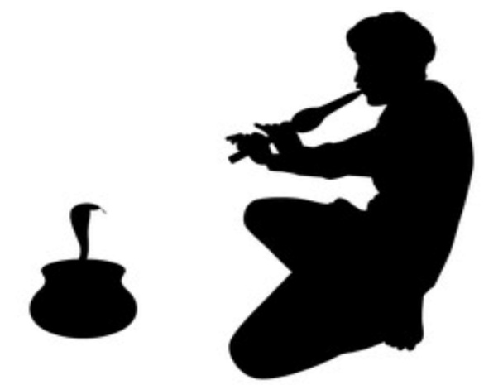

After observing the picture, say how does the snake most likely perceive (understand ) the music.
a. Through the air as sound waves.
b. By vibrations in the ground caused by the music.
c. By sensing the heat from the instrument.
d. Through its skin as it is directly touching the instrument

